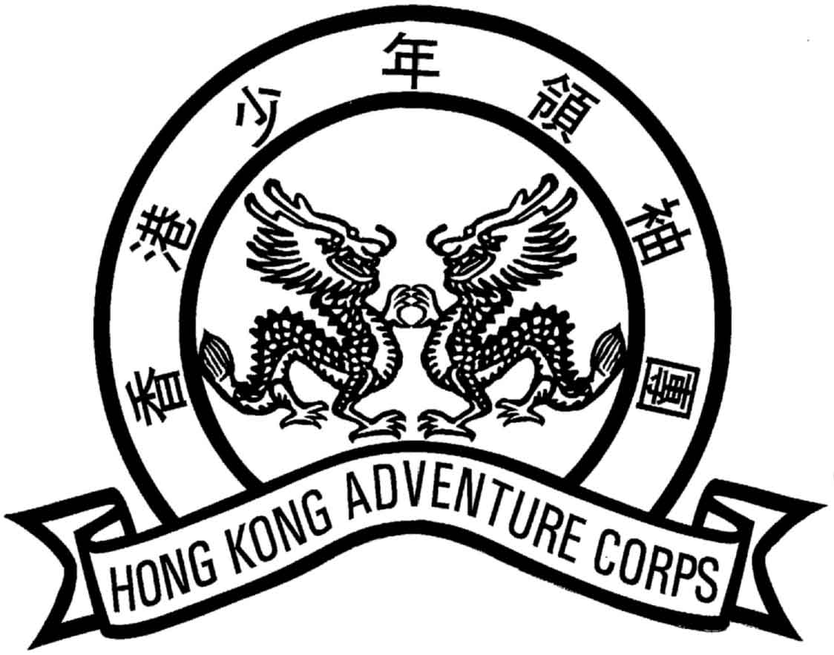
香港少年領袖團 HONG KONG ADVENTURE CORPS
學員註冊更新表格MEMBERSHIP RENEWAL FORM FOR CADETS
(Aged below 18)
中文姓名 |  |  |  |  |  |  |  |  |  |  |  |  |  | English Name |  |  |  |  |  |  |  |  |  |  |  |  |  |  |  |  |  |  |  |  | (Surname first)
香港身分證號碼HKID Card No. |  |  |  |  |  |  |  |  |  |  |  |  |  | 出生日期Date of Birth |  |  |  |  |  |  |  |  |  |  | (d/m/y)
性別 Sex | 男 Male / 女 Female |  |  |  |  |  |  |  |  |  |  | 職業Occupation
學校／機構名稱Name of School / Organization
學校／機構地址
School / Organization Address
住址Home Address
聯絡電話號碼Contact Telephone No. |  |  |  |  |  |  |  |  |  |  |  |  |  |  |  |  |  |  | 傳真號碼Fax
電郵地址Email Address |  |  |  |  | (請用大楷In Block Letters)
教育程度Education
家長／監護人姓名Name of Parent/Guardian |  |  |  |  |  |  |  |  |  |  |  |  |  |  |  |  |  |  |  |  |  |  | (English) |  |  |  |  |  |  |  |  |  |  |  |  | (中文)
聯絡電話號碼Contact Telephone No. |  |  |  |  |  |  |  |  |  |  |  |  |  |  |  |  |  |  |  |  |  |  | 關係Relationship
1. 香港少年領袖團服務紀錄Hong Kong Adventure Corps Service Record
入伍日期Date of Enlistment |  |  |  |  |  |  |  |  |  |  |  |  |  |  |  |  | 現時職級Present Rank
委任紀錄Posting History
職級Rank |  | 中隊Squadron |  |  |  |  |  | 期間Period |  |  |  |  |  |  |  | 職級Rank |  |  |  |  |  | 中隊Squadron |  |  |  |  |  |  |  |  |  |  |  | 期間Period
見習學員Recruit
2. 其他義務工作服務經驗Other Voluntary Experience
機構名稱Name of Organization |  |  |  |  |  |  |  |  |  |  |  |  | 服務種類Kind of Service |  |  |  |  |  |  |  |  |  |  |  |  |  |  |  |  |  | 服務期間Service Period
3. 考獲資歷Qualifications Obtained
技能 / 有關經驗  Skills /Relevant  Experience |  |  | 技能Skills |  |  |  |  |  |  |  | 考獲日期Date Obtained |  |  |  |  |  |  | 技能Skills |  |  |  |  |  |  |  |  |  |  |  |  |  | 考獲日期Date Obtained
其他Others (請列明please specify) |  |  |  |  |  |  |  |  | 機構Organization |  |  |  |  |  |  |  |  |  |  |  |  |  |  |  |  |  |  |  |  |  | 發出日期Date of Issue
4. 獎勵Awards
頒發機構Award Organization |  |  |  |  |  |  |  |  |  | 獎勵Award |  |  |  |  |  |  |  |  |  |  |  |  |  |  |  | 發出日期Date of Issue
申請人簽署  Applicant’s signature ： |  |  |  |  |  |  |  |  |  |  |  |  |  |  |  |  |  |  |  |  |  |  |  | 日期  Date：

家 長 ／ 監 護 人 同 意 聲 明 Parent/Guardian’s Consent
本人同意參加者繼續參加香港少年領袖團，並聲明他／她身體並無任何疾病，令他／她不宜參加香港少年領袖團所舉辦的訓練及活動。如果因參加者的疏忽或健康或體能欠佳，以致在參加活動時傷亡，香港少年領袖團及其安排活動的有關人士毋須負上任何責任。
I agree the afore-named cadet to continue participating in Hong Kong Adventure Corps' training and activities and declare that he/she does not suffer from any illness that renders him/her unfit for the activities. The Hong Kong Adventure Corps and its members shall not be liable for any injury or death which the participant may suffer in this activities, if the cause of injury or death is due to his/her negligence or inadequacy in health and fitness.
家長／監護人簽署  Parent/Guardian’s signature ： |  | 日期  Date：
此欄由本團填寫 For Official Use
Sqn |  | Handled by |  | Annual Fee / Card Fee
Corps No. |  | Dbase Updated by |  | Card Issued by:

